# PyTorch

查看NVIDIA GPU驱动版本

nvidia-smi

查看CUDA toolkit

nvcc -v

conda update conda

conda update anaconda

conda update python

conda update --all

conda config --add channels <https://mirrors.tuna.tsinghua.edu.cn/anaconda/pkgs/free/>

conda config --add channels https://mirrors.tuna.tsinghua.edu.cn/anaconda/pkgs/main/

conda config --add channels https://mirrors.tuna.tsinghua.edu.cn/anaconda/cloud/pytorch/

conda config --add channels https://mirrors.tuna.tsinghua.edu.cn/anaconda/cloud/conda-forge/

conda config --add channels https://mirrors.tuna.tsinghua.edu.cn/anaconda/cloud/msys2/

conda config --set show_channel_urls yes

conda config --remove channels https://mirrors.tuna.tsinghua.edu.cn/anaconda/cloud/conda-forge/

conda config --show

conda create –n pytorch python=3.6

conda activate pytorch

conda deactivate pytorch

conda install pytorch torchvision torchaudio cudatoolkit=10.2 –c pytorch

python

import torch

print('gpu:', torch.cuda.is_available())

# Sekiro

conda create –n sekiro python=3.6

conda activate sekiro

查看tensorflow-gpu与cuda的适配版本

<https://tensorflow.google.cn/install/source?hl=en#linux>

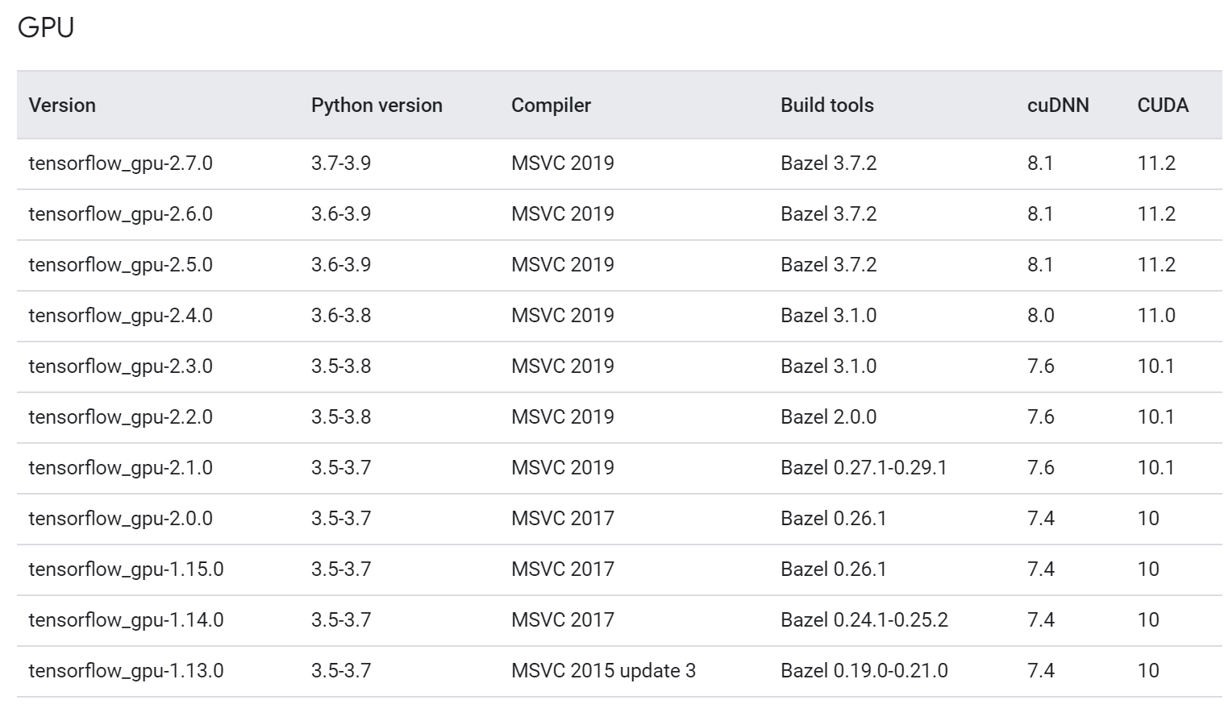

conda search tensorflow-gpu

conda install tensorflow-gpu=2.1.0 –y

conda install opencv=4.5.3

conda install pillow

conda install pywin32

conda install gym=0.18.0

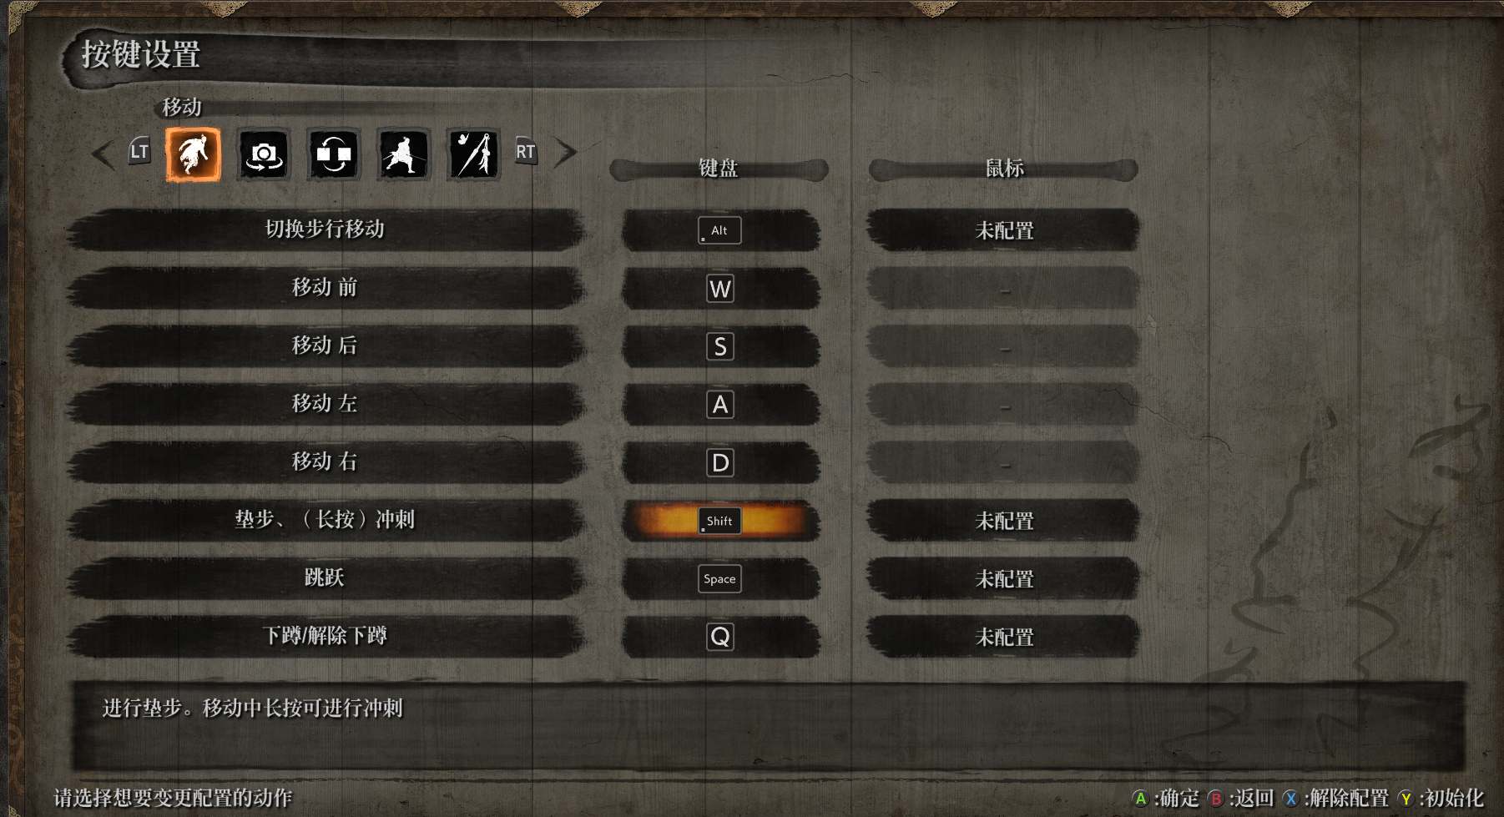

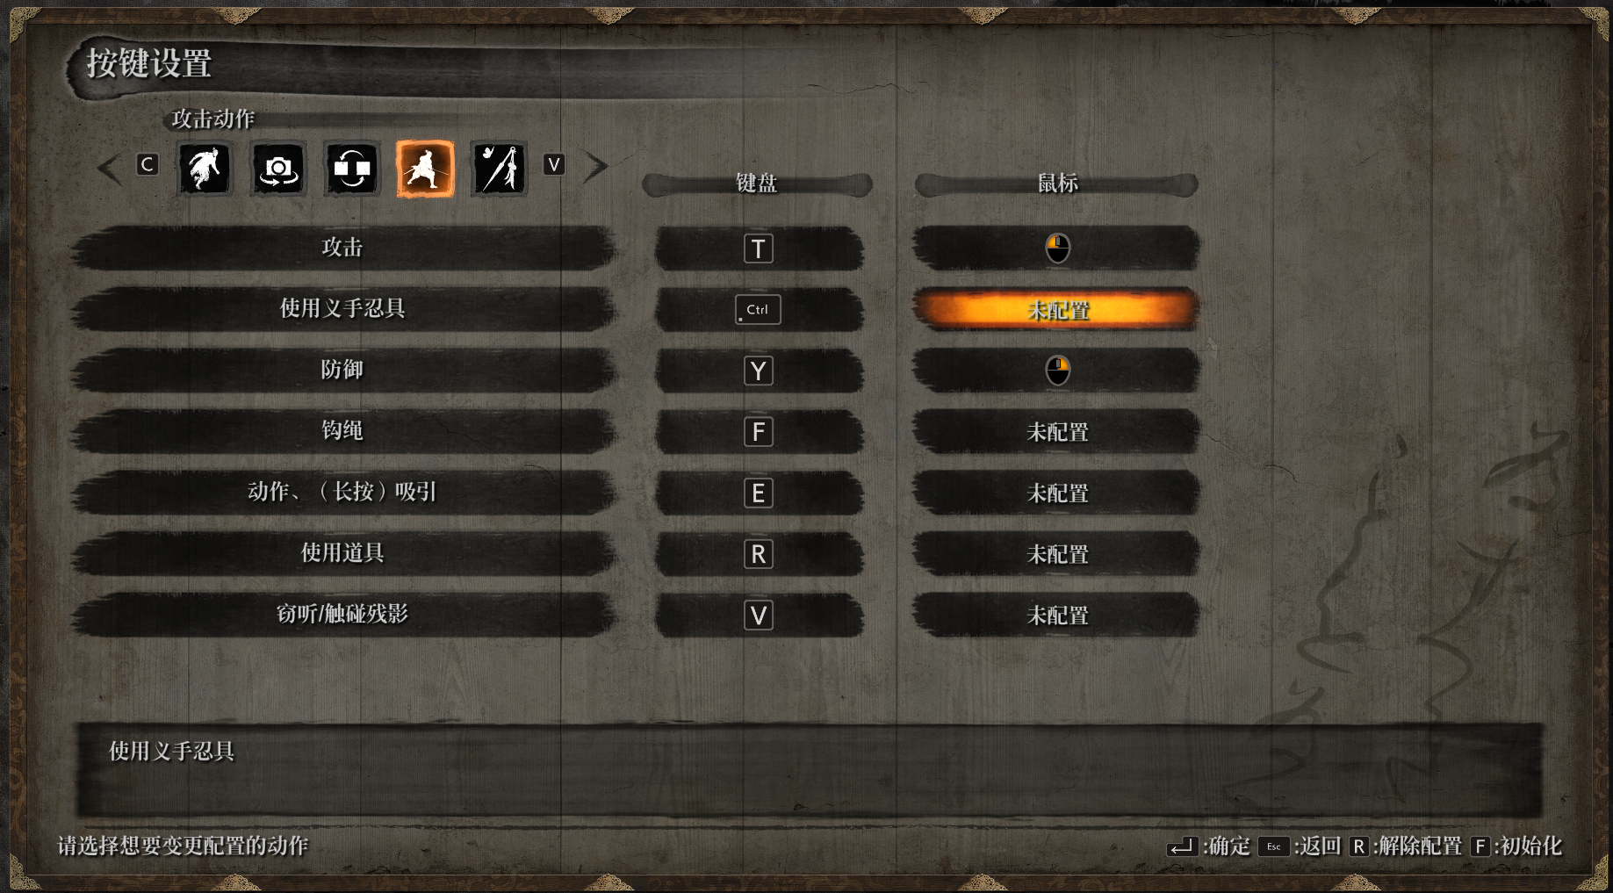

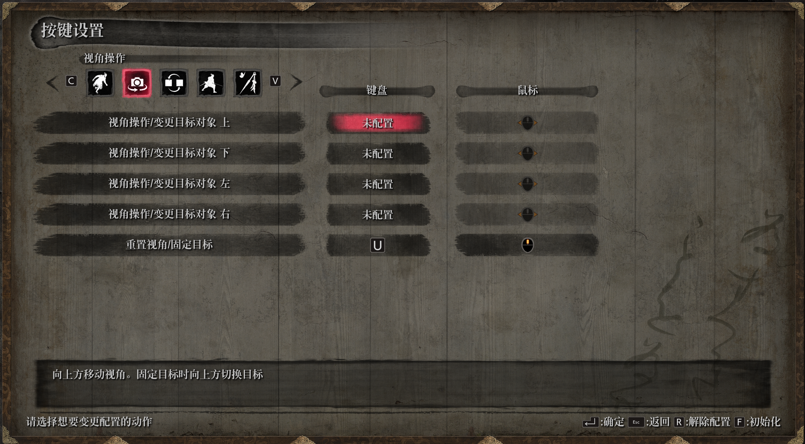

存档文件位于

C:\Users\Administrator\AppData\Roaming\Sekiro